**The Battle of Neighborhoods**

**OR**

**Where to Build a Restaurant in NYC on the Basis of Rarity of Food Offerings per Neighborhood**

Benjamin Scullard

August 2020

**Introduction:**

Someone would like to open a restaurant in New York City. This someone is not exactly sure where in New York City to set up shop, but they do know that they would like to open their restaurant in a place with as little competition from other food-selling businesses as possible, thinking that this will be better for their business. A restaurant located in a region already packed with other restaurants will go completely unnoticed. Therefore, the goal of this project is to take the neighborhoods of New York City, and determine which ones have the fewest food-serving venues so that the aforementioned restaurant may move in.

**Data:**

The data that shall be used is the Foursquare location data; specifically, the ability to determine what kinds of venue are most common in each neighborhood in New York City (e.g. is a particular region rife with coffee shops? Or perhaps diners? etc.). With this data, it can be determined which neighborhoods in New York City have the fewest food-serving establishments, and therefore, where a restaurant could be created and have minimal competition.

**Methodology:**

The Foursquare location data was used to pull up a list of every neighborhood in New York City, the location of each one on a map, the number of venues per neighborhood, the mean of the frequency of each type of venue in every neighborhood, and the top ten most common varieties of venue in every neighborhood. For example, in the neighborhood that is alphabetically first, Allerton, the 1st through 10th most common venues are pizza places, delis/bodegas, supermarkets, Chinese restaurants, department stores, grocery stores, check cashing services, bus stations, martial arts schools, and fast food restaurants. A list of what qualified as a food-serving establishment was made, consisting of any venue with “Restaurant” in its name, and the following:

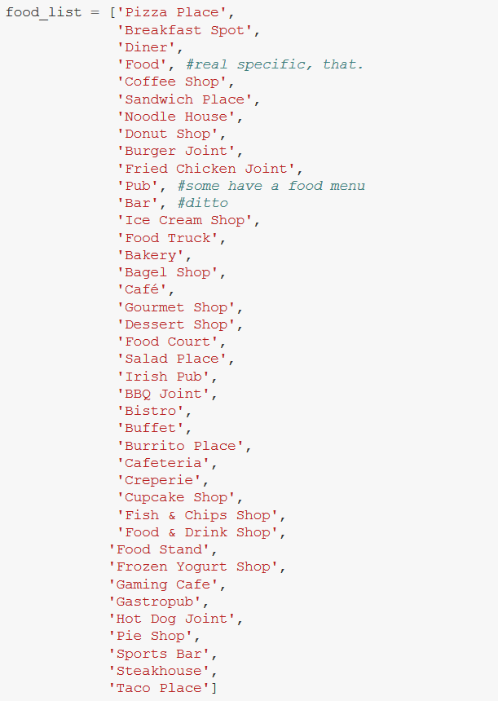

Grocery stores and supermarkets technically serve food, but customers are not expected to eat there, so they were not included on the list. Additionally, venues that specialized more in drinking than eating, such as cocktail bars, were also not included on this list. A loop was used on the Dataframe displaying neighborhoods and their most common venues to count how many “Most Common” spots were occupied by a food venue in each neighborhood.

**Results:**

According to the parameters of this project, the logical best place for a restaurant to open would be in a neighborhood where zero “Most Common” spots are occupied by food-serving establishments. However, no such neighborhood exists in New York City. Therefore, the logical next best place to open a restaurant is a neighborhood with only one “Most Common” spot taken by a business that sells food. Five such neighborhoods exist: Bergen Beach, Breezy Point, Clason Point, Fieldston, and Queensbridge.

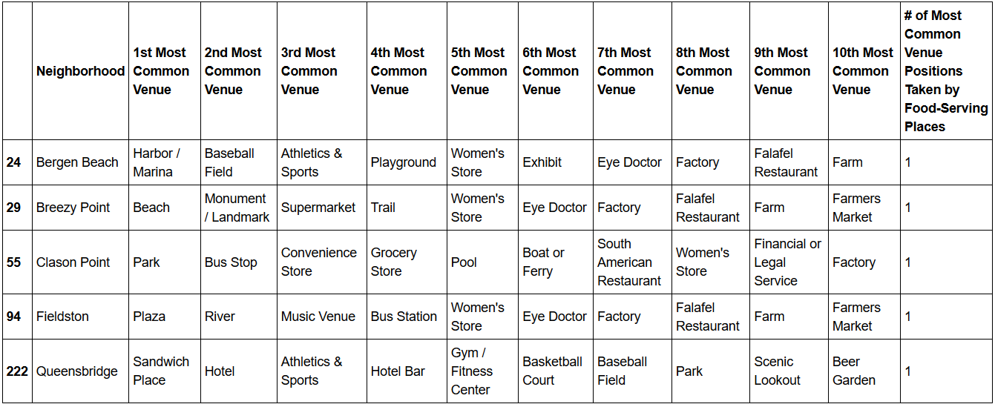

Conversely, the worst place to open a restaurant would be a neighborhood with all ten “Most Common” spots taken by food servers. But again, no such neighborhood is that saturated, so the actual worst neighborhoods to open one are neighborhoods with nine “Most Common” spots taken by food businesses. Those are Bayside, Park Slope, Sheepshead Bay, Upper West Side, and Woodside.

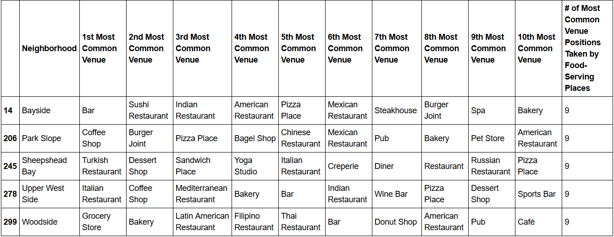

**Discussion:**

If one wanted to open a restaurant in New York City, considering the number of food options already existing in a neighborhood is certainly a valuable factor to observe. However, it is by no means the singular defining factor in deciding whether a new restaurant will thrive in a particular location. For example, if a restaurant is too remote from where likely customers are located, that will hamper success unless the restaurant is high enough in quality to warrant the trip. This project also does nothing to ask what variety of restaurant is opening up in the first place; someone who wants to open a pizzeria will not want to open in a region that has more pizzerias as its competition, even if they are the only other food options in the neighborhood.

This project is not the most comprehensive, unsurpassable guide of where a restaurant should open, with all possible factors being taken into consideration; this project only takes into account the rarity of food options in all of New York City’s neighborhoods, meant to be used in tandem with other guides to determine the best possible restaurant location. That said, a neighborhood with less competition will most likely be more useful to a starting restaurant than a neighborhood with more.

**Conclusion:**

In short, study of the Foursquare location data indicates that food-serving options are rarest in the neighborhoods of Bergen Beach, Breezy Point, Clason Point, Fieldston, and Queensbridge, and therefore, are the best places to open a restaurant in New York City on the basis of the rarity of other dining options.